User Manual
Constituency Level Development Monitoring System (CLDMS)
https://cldms.planning.telangana.gov.in/
Enter the login credentials in the login page.
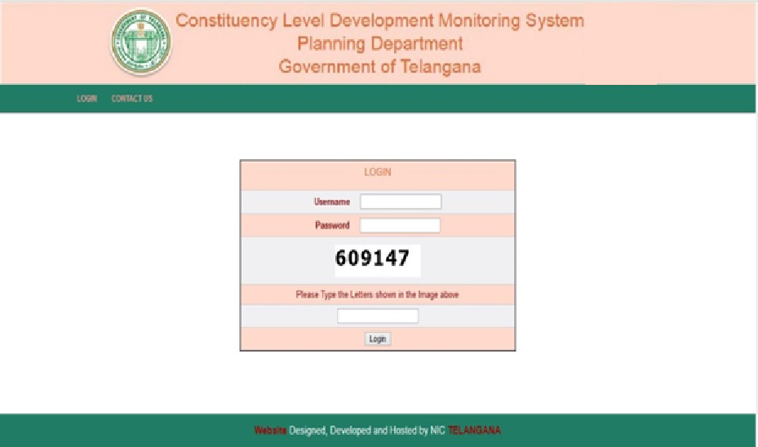
After successful login,welcome page will be displayed as shown below.
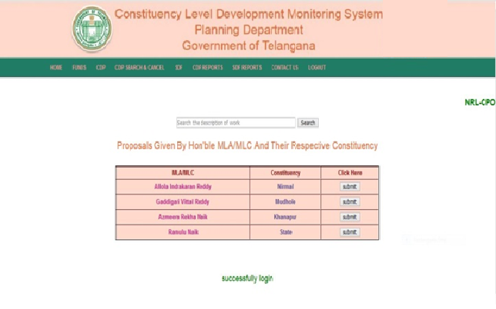
The following modules are available in this application

- Funds Entry | - CDP
- CDP Search & Cancel | - SDF
- CDP Reports | - SDF Reports

- Funds Entry
  - Entry
    - Constituency wise
    - Category wise
  - Report
    - Constituency wise
    - Category wise
To enter the details of Funds Constituency wise and Category wise
a) Entry – Constituency wise option.Enter the fund details for consituency
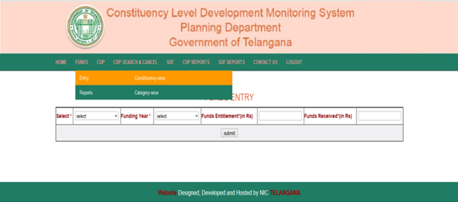

b) Entry- Category wise option. Enter the fund details category wise
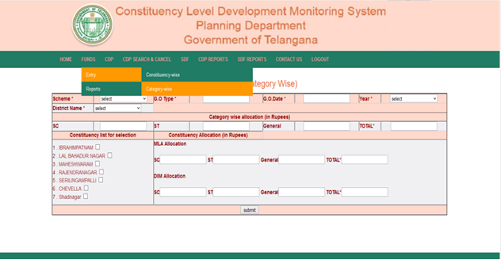
For fund reports go to Funds and depending upon the requirement select Report -
a) Report Constituency – wise is to view the details of constituency wise fund
details.
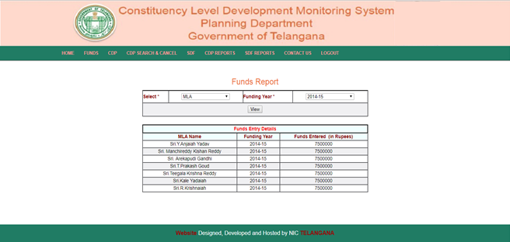

b) Report Category – wise is to view the details of category wise fund details.
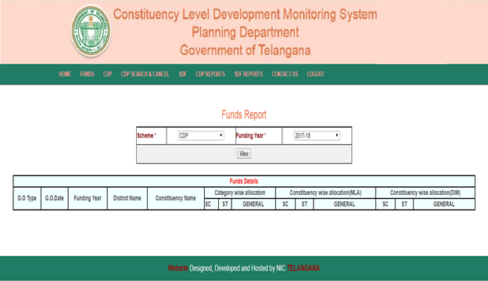
- CDP
  - Proposal
    - Proposal Entry
    - Edit Proposal
    - Edit Freezed Proposal
  - work
    - Works Edit
    - Installment Edit
    - Freezed Works edit
    - View work details
CDPProposalProposal Entry
Work Proposal details are captured using this option. All the details needed to entered
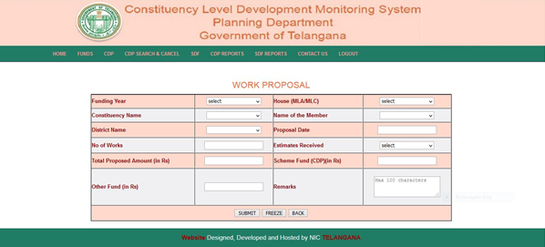
Submit Button is used to save the record. User can Edit and Delete the Workproposal.
Freeze Button is used to Freezed the Proposal. Once the Proposal is freezed user can cancel and edit. No delete is permitted.
Back Button is used to move to the prievous page.
After successful submit the following sceen will be displayed.To Edit/Delete a submitted proposal click on Edit/Delete button.
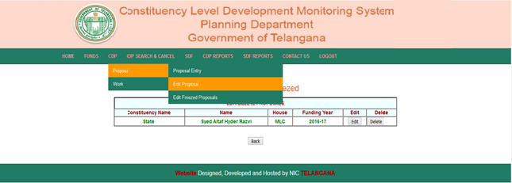

After clicking Edit,the following page is displayed.
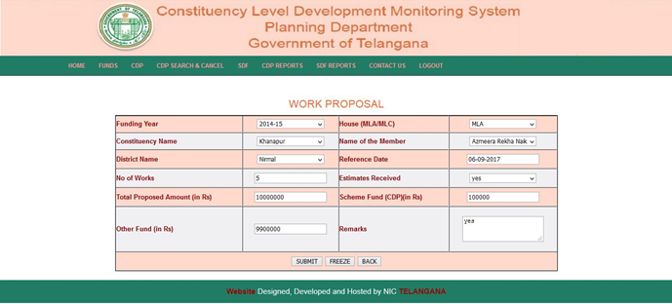

To Freeze the proposal click on “Freeze” button and the below page will be displayed.
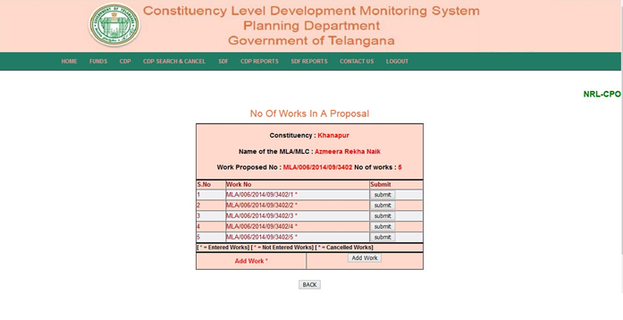

By clicking submit button of the above page, Work Entry details page will be displayed as below.

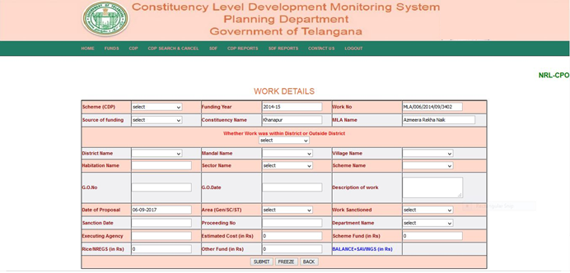

After submitting the work the below page is displayed .
Edit button is used to edit the work.
Delete button is used to delete the work.
Back button is used to move to the previous page.
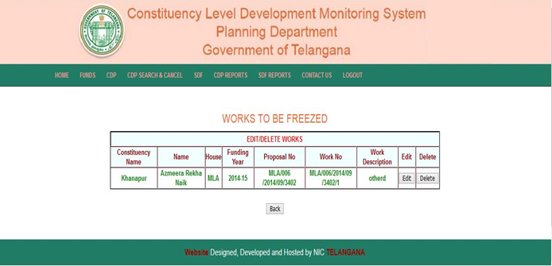

To freeze Work details click on Freeze button. Once a work is freezed one can either Edit/Cancel the work .
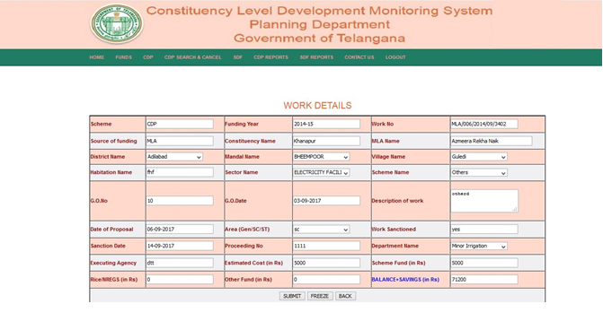

After freezing Work details, enter installment details of particular work.
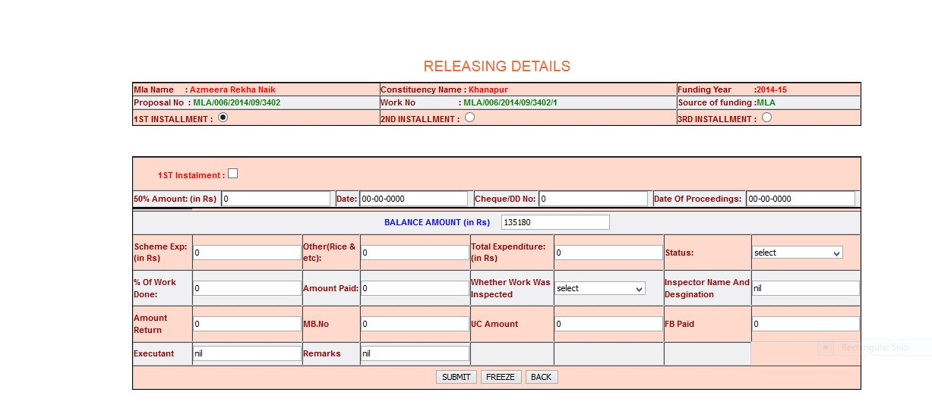

After submitting Installment details below page will be displayed.
Edit button is used to edit an installment.
Delete button is used to delete installment.

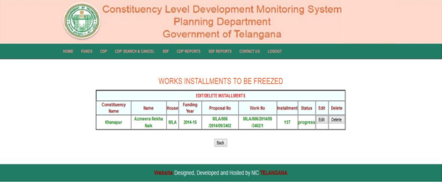

To Freeze Installment details click on Freeze button. Afer freezing we can either Edit/Cancel the Installment.
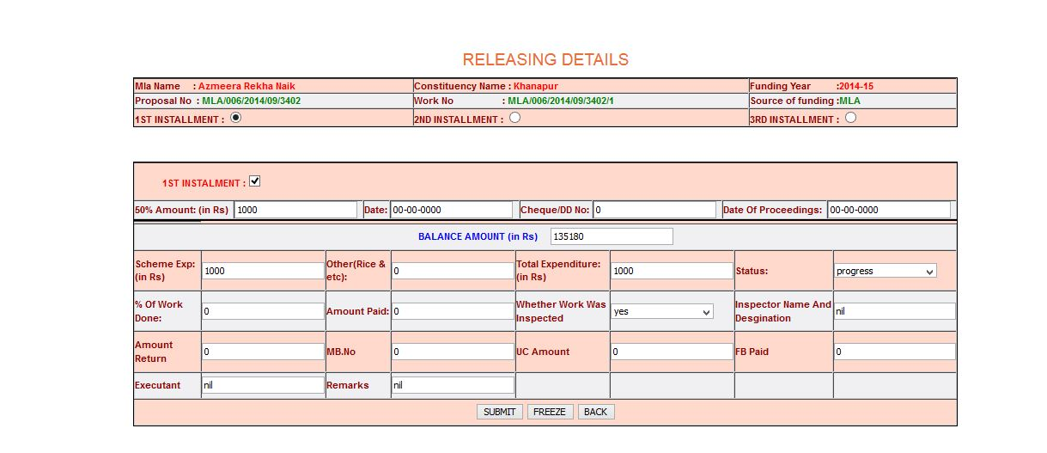

After freezing the below page will be shown.

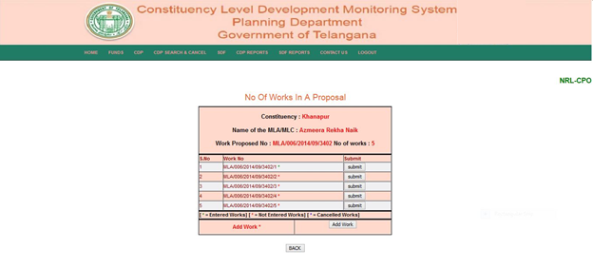

To Edit a freezed Proposal go to CDP and select Proposal and then Edit Freezed Proposals. Enter the proposal number.

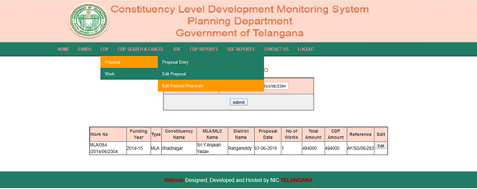

Now edit the Proposal and click on update as shown below.

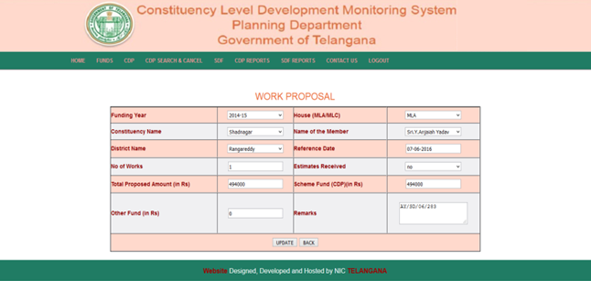

To Edit a freezed Proposal go to CDP, select Work and then Freezed Works Edit . Enter the Work number.

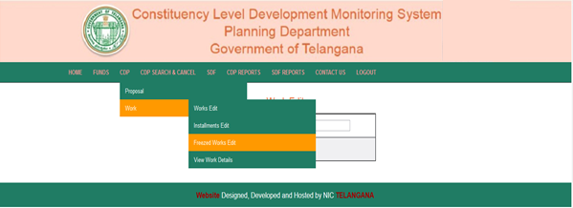
After entering work number the below page will be shown. Edit the details and click on Update.
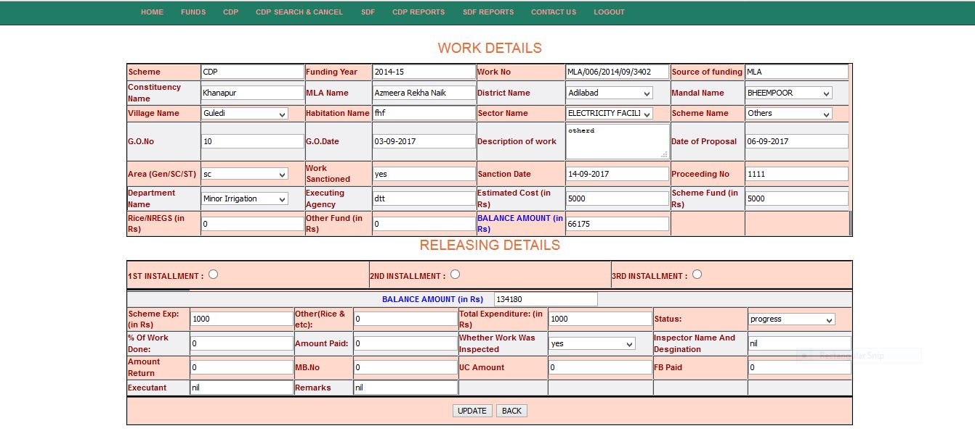

To view CDP Work details go to CDP select Work and then View Work Details.

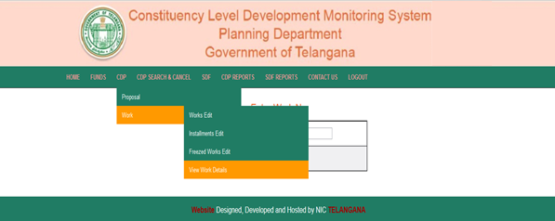

After entering work number, Work details will be shown as below.

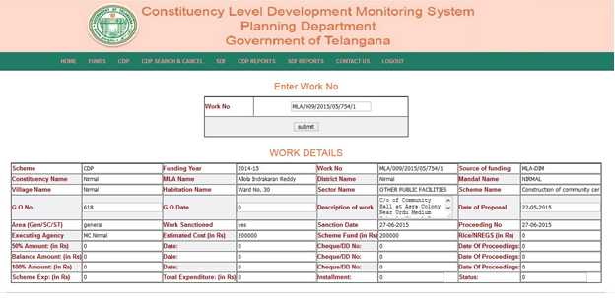

- CDP Search & Cancel
  - Search Proposal
  - Search Installment
  - Search description
  - Cancel Freezed Works
CDP Search & Cancel Search Proposal
This option is used to search the proposal details.
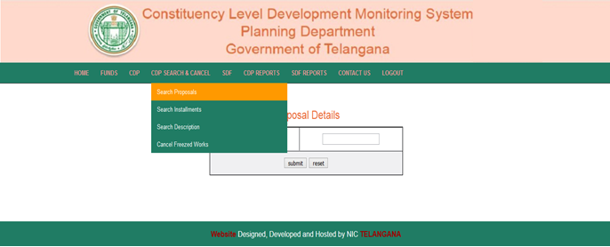

After entering Proposal number the details will be shown as below. User can select Submit Button for the normal workflow.

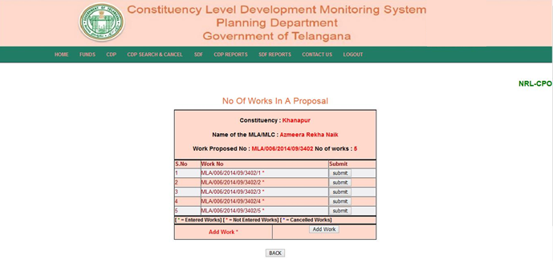

CDP Search & Cancel Search Installments
This option is used to search Installments of the Works
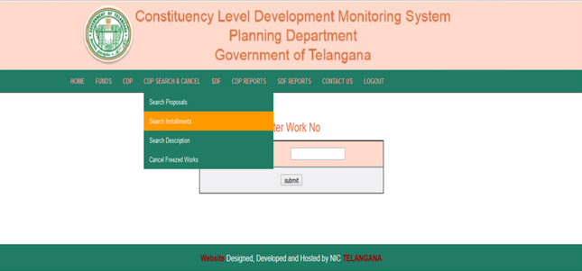

After giving Work number the Installment details will be shown.
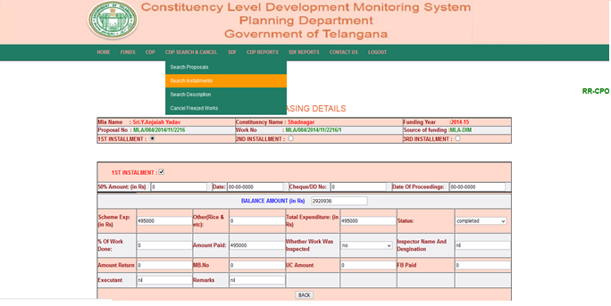

To search for Description click on Search Description in CDP Search & Cancel menu.
CDP Search & Cancel Search Description
Enter the details of search and click on search button.

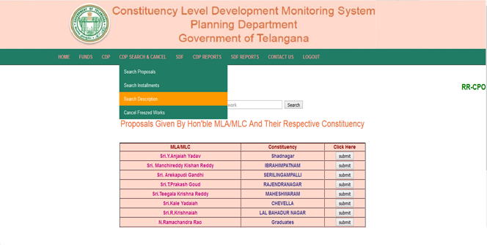

The works will be displayed based on entered description.
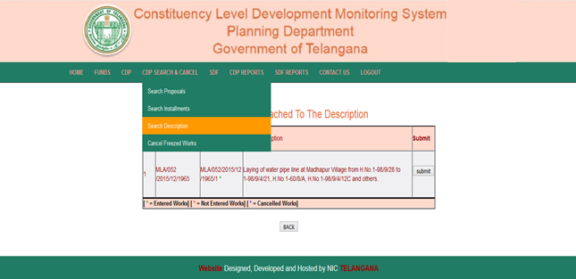

To cancel freezed works got to CDP Search &Cancel and select Cancel Freezed Works.
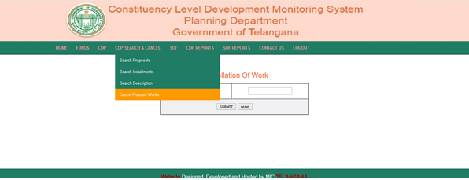

The respective works of a entered proposal will be shown.
Click on Cancel button toc cancel the freezed work.
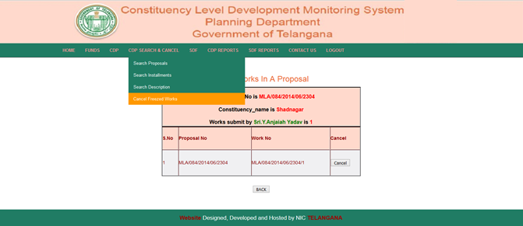

If we add the Work of a proposal click add button of the below page.
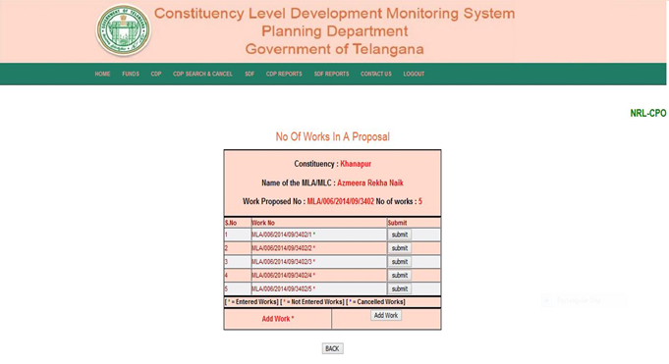
- SDF
  - Work Entry
  - Installment Edit
  - Works(View/Edit/Delete)

SDF Work Entry
To enter the SDF Works go to SDF and select Work Entry.

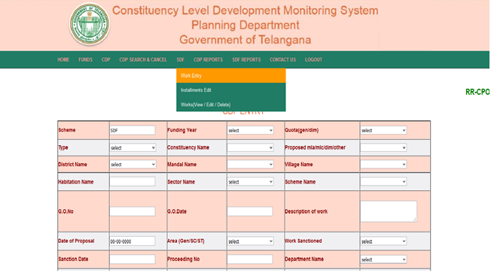

After submitting the Work details we have to give the Installment details of below page.
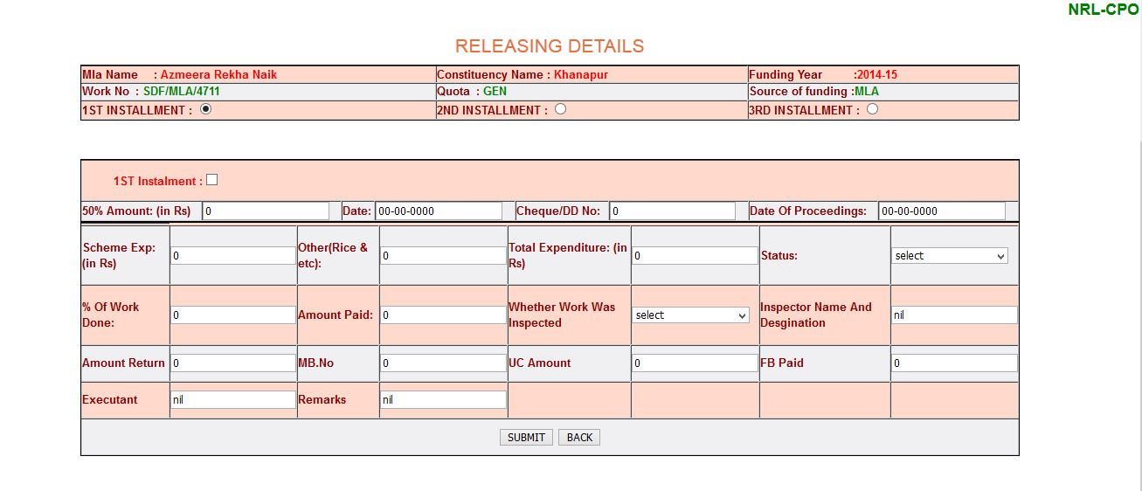
After submitting the Installment details below page is displayed.
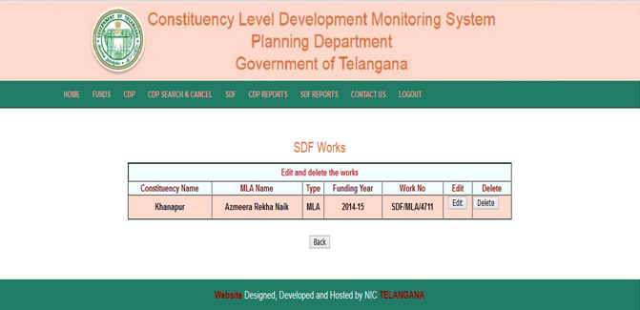

Edit button is used edit the SDF works.
Delete button is used to delete the works of SDF.

SDF Installment Edit.
To edit installments in SDF go to SDF and select Installment Edit and give Work number.

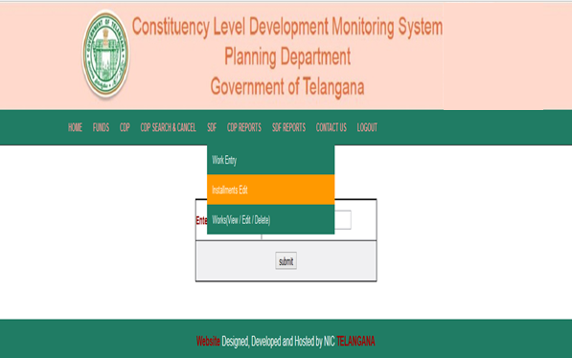

After giving SDF work number we need to Edit the details and then Submit.
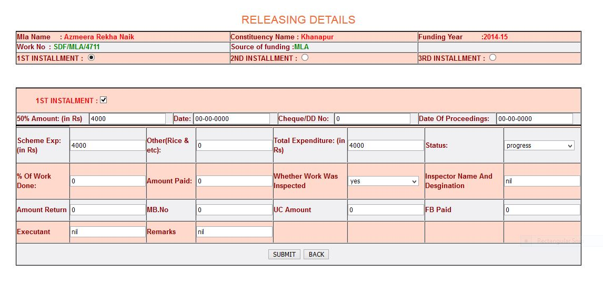

SDF Works (View/Edit/Delete)
To View/Edit/Delete works in SDF go to SDF and select Works(View/Edit/Delete).
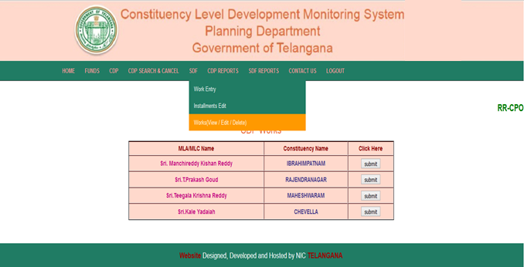

By clicking Submit button of above page the respective works will be displayed as shown below.
Edit button is used to edit the work.
Delete button will delete the work.

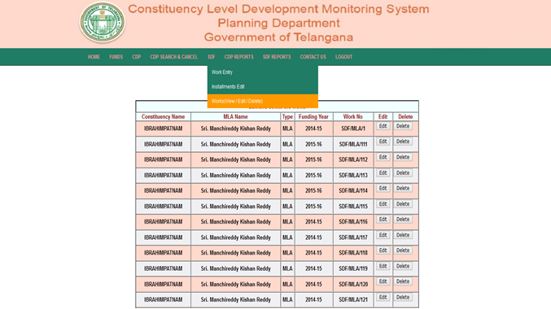

5. CDP Reports
- Physical & Financial Progress (Constituency)
- Physical & Financial Progress (District)
- Physical & Financial Progress (Sector)
- Physical & Financial Progress (Work Description)
- Physical & Financial Progress (Department Wise)
- Physical & Financial Progress (Year Wise)
- Physical & Financial Progress (Within District)

To view CDP Physical & Financial Progress (Constituency) Reports go to CDP and
click Physical & Financial Progress (Constituency).

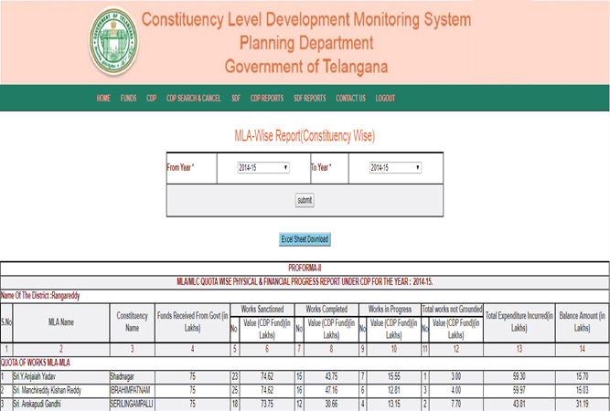

To view CDP Physical & Financial Progress (District) Reports go to CDP and
click Physical & Financial Progress (District).

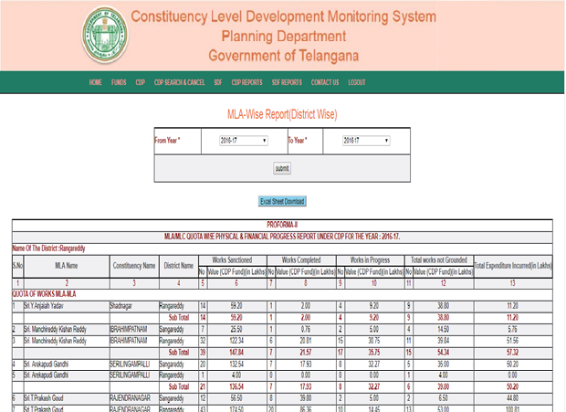

To view CDP Physical & Financial Progress (Sector) Reports go to CDP and
click Physical & Financial Progress (Sector).

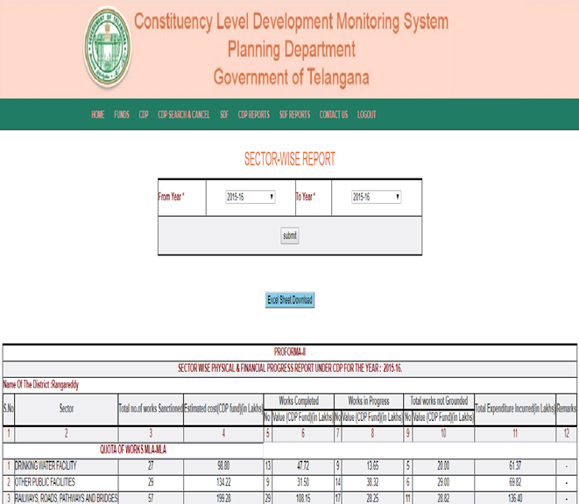

To view CDP Physical & Financial Progress (Work Description) Reports go to CDP and click Physical & Financial Progress (Work Description).

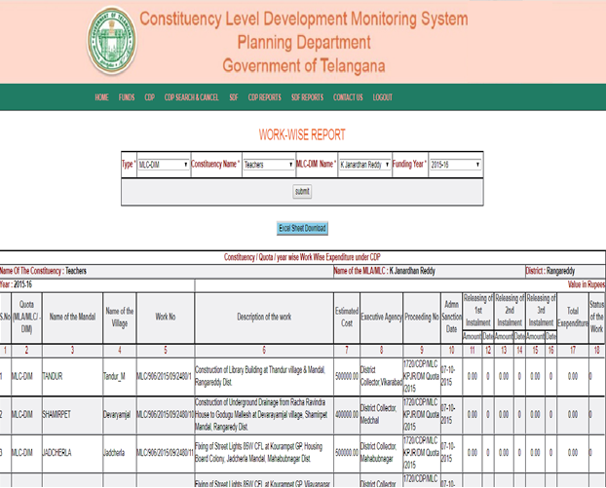

To view CDP Physical & Financial Progress (Department wise) Reports go to CDP and click Physical & Financial Progress (Department wise).
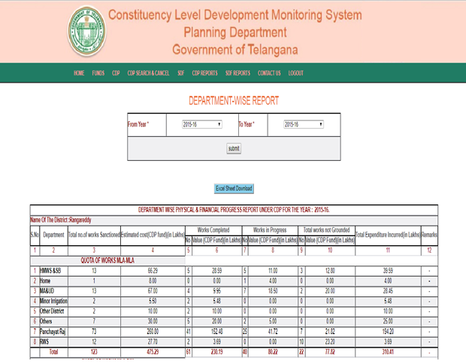

To view CDP Physical & Financial Progress (Year wise) Reports go to CDP and click Physical & Financial Progress (Year wise).

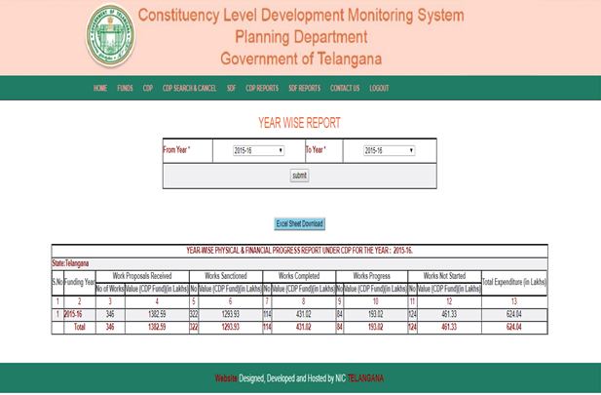

To view CDP Physical & Financial Progress (Within District) Reports go to CDP and click Physical & Financial Progress (Within District).

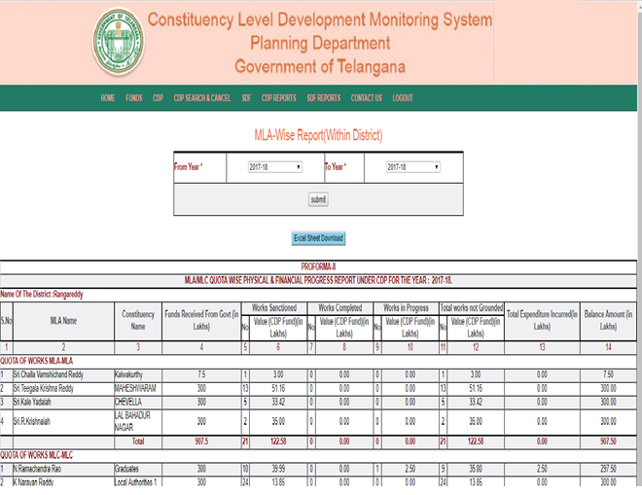

6.SDF Reports
- Physical & Financial Progress (Work Description)
- Physical & Financial Progress (Work wise Status)
- Physical & Financial Progress (Schedule Area)

To view SDF Physical & Financial Progress (Work Description) Reports go to SDF and click Physical & Financial Progress (Work Description).

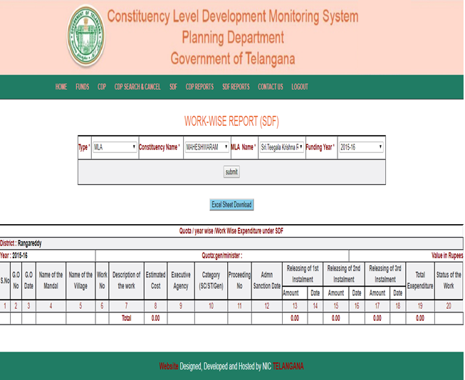

To view SDF Physical & Financial Progress (Work wise Status) Reports go to SDF and click Physical & Financial Progress (Work wise Status).
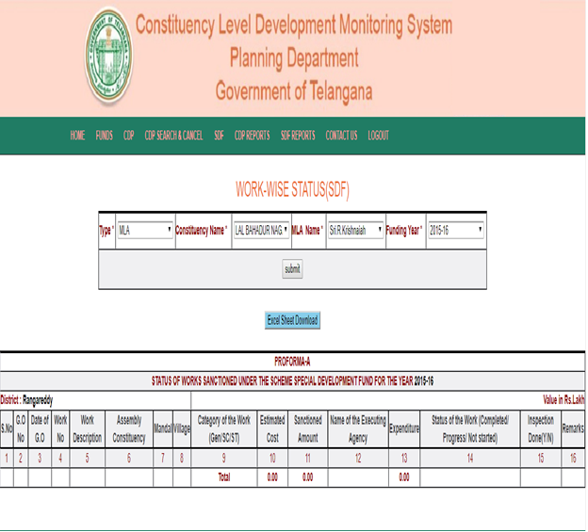

To view SDF Physical & Financial Progress (Schedule Area) Reports go to SDF and click Physical & Financial Progress (Schedule Area).

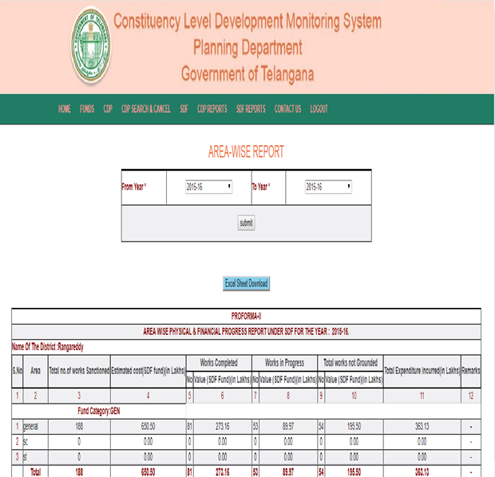

For State Login
Enter the State login credentials in the login page.

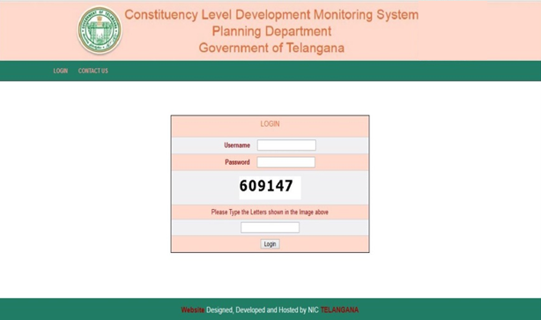

The modules in this login are
1. Funds | 2. CDP Reports
3. SDF Reports

- Funds Entry
  - Entry
    - Constituency wise
    - Category wise
  - Report
    - Constituency wise
    - Category wise

To enter the details of Funds Constituency wise and Category wise
a) Entry – Constituency wise option.Enter the fund details for consituency
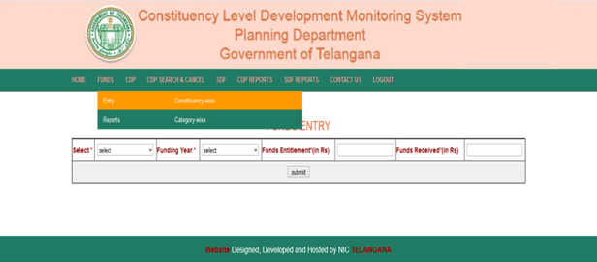

b) Entry- Category wise option. Enter the fund details category wise
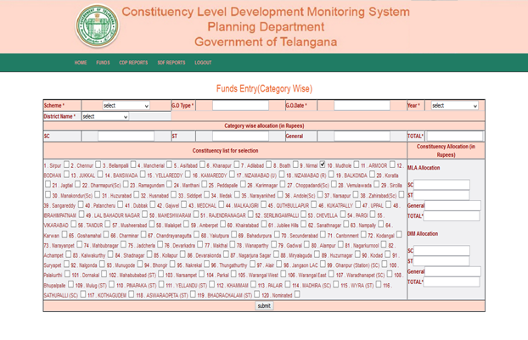
For fund reports go to Funds and depending upon the requirement select Report -
a) Report Constituency – wise is to view the details of constituency wise fund
details.
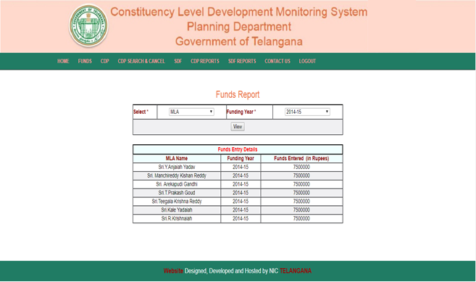

b) Report Category – wise is to view the details of category wise fund details.
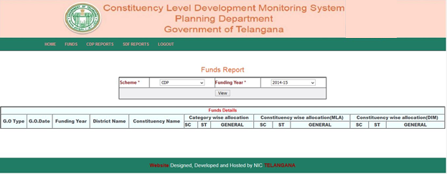
2. CDP Reports
a. Physical & Financial Progress (DISTRICTS)
To view CDP Physical & Financial Progress (DISTRICTS) Reports go to CDP and
click Physical & Financial Progress (DISTRICTS).

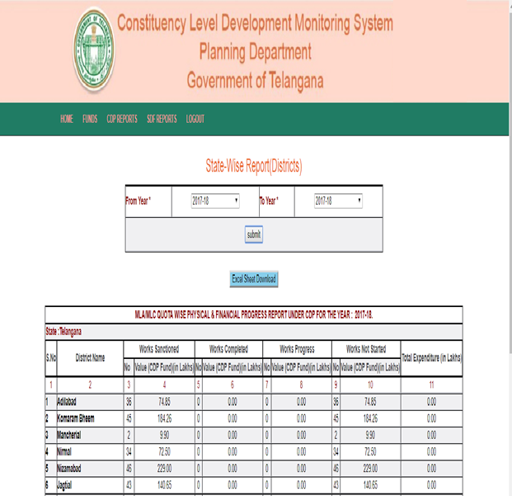

b. Physical & Financial Progress (MLA/MLC’s)
To view CDP Physical & Financial Progress (MLA/MLC’s) Reports go to CDP
and click Physical & Financial Progress (MLA/MLC’s).

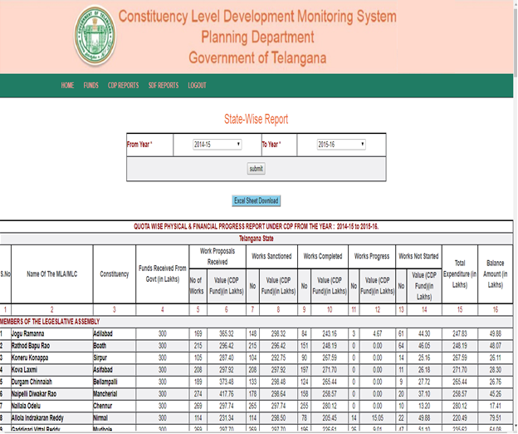

c. Physical & Financial Progress (scheme wise DISTRICTS)
To view CDP Physical & Financial Progress (scheme wise DISTRICTS) Reports
go to CDP and click Physical & Financial Progress (scheme wise DISTRICTS).

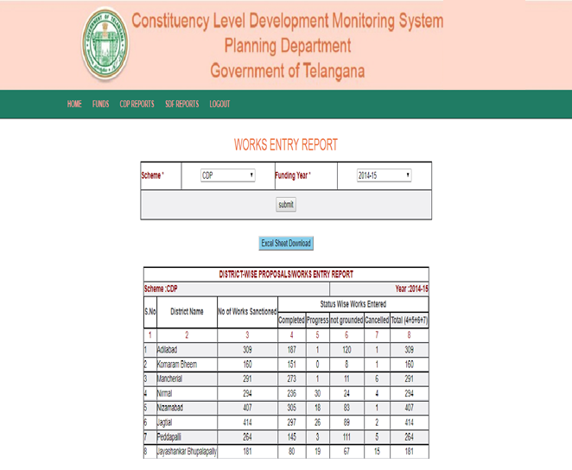

d. Physical & Financial Progress (Year Wise)
To view CDP Physical & Financial Progress (Year Wise) Reports go to CDP and
click Physical & Financial Progress (Year Wise).

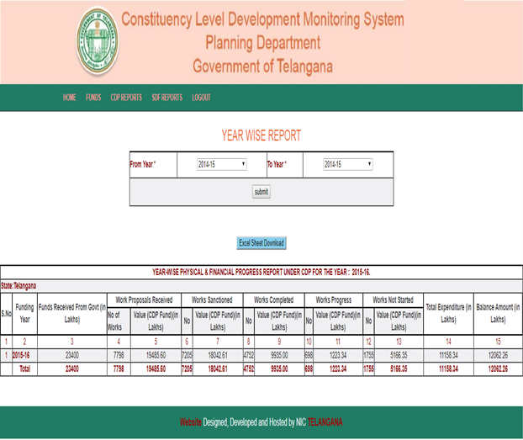

e. Physical & Financial Progress (Department Wise)
To view CDP Physical & Financial Progress (Department Wise) Reports go to
CDP and click Physical & Financial Progress (Department Wise).
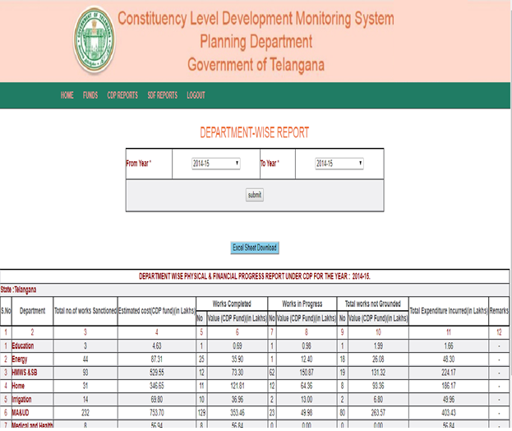

f. Physical & Financial Progress (Sector Wise)
To view CDP Physical & Financial Progress (Sector Wise) Reports go to
CDP and click Physical & Financial Progress (Sector Wise).
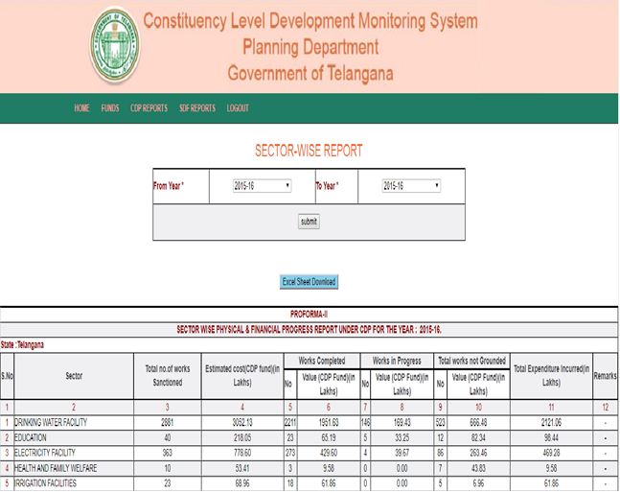

g. Physical & Financial Progress (MLA/MLC District wise)
To view CDP Physical & Financial Progress (MLA/MLC District wise) Reports
go to CDP and click Physical & Financial Progress (MLA/MLC District wise).
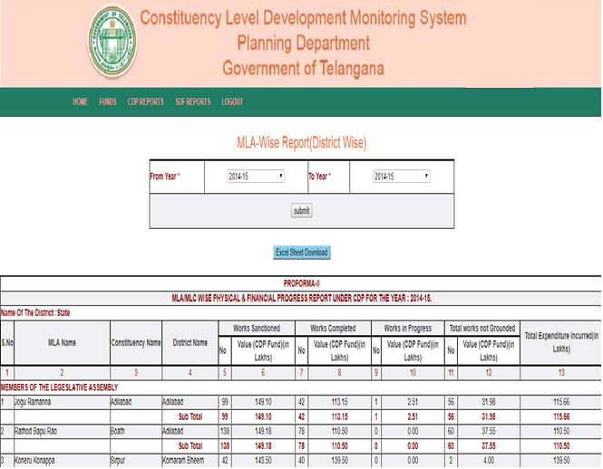

h. Physical & Financial Progress (State-MLC’s)
To view CDP Physical & Financial Progress (State-MLC’s) Reports
go to CDP and click Physical & Financial Progress (State-MLC’s).
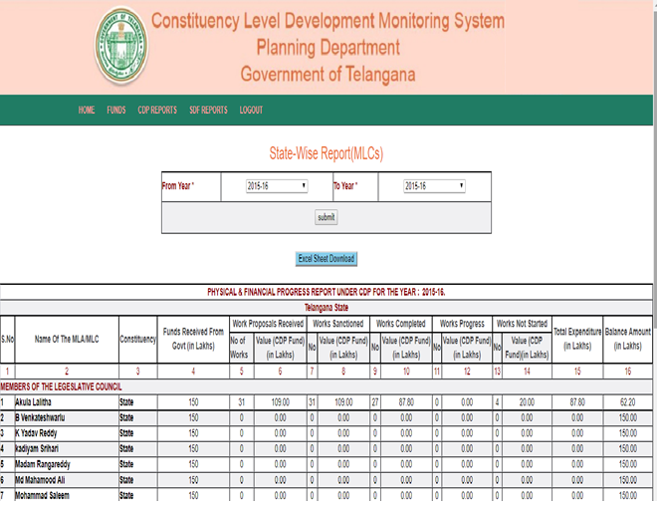

i. Physical & Financial Progress (Area wise Description)
To view CDP Physical & Financial Progress (Area wise Description) Reports
go to CDP and click Physical & Financial Progress (Area wise Description).
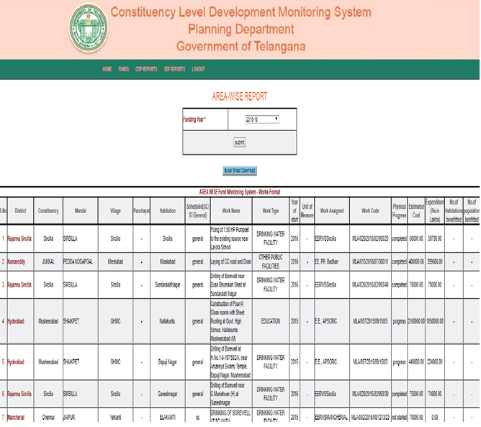

3. SDF Reports
a. Physical & Financial Progress (scheme wise Districts)
To view SDF Physical & Financial Progress (scheme wise Districts) Reports
go toSDF and click Physical & Financial Progress (scheme wise Districts).

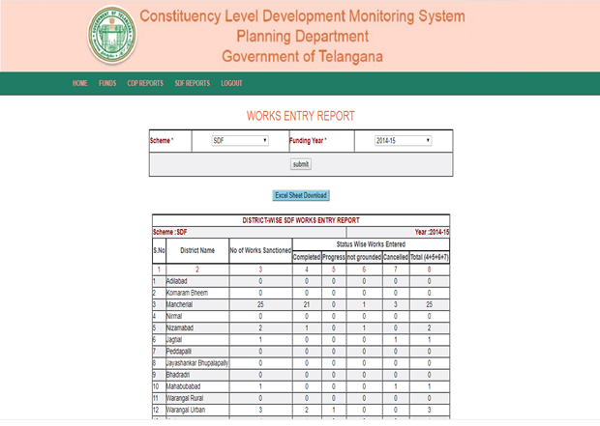

b. Physical & Financial Progress (DISTRICTS)
To view SDF Physical & Financial Progress (DISTRICTS) Reports go toSDF and
click Physical & Financial Progress (DISTRICTS).
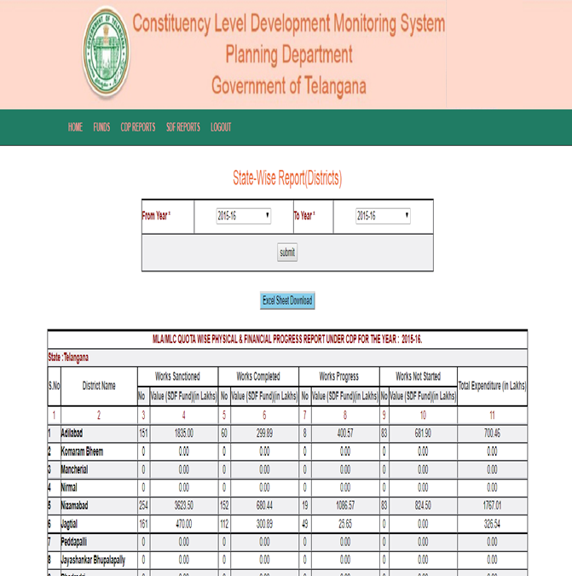

c. Physical & Financial Progress (Scheduled Area)
To view SDF Physical & Financial Progress (Scheduled Area) Reports go toSDF
and click Physical & Financial Progress (Scheduled Area).

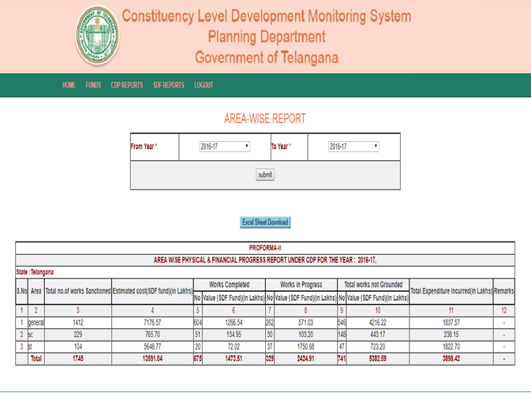

d. Physical & Financial Progress (Work Wise)
To view SDF Physical & Financial Progress (Work Wise) Reports go
toSDF and click Physical & Financial Progress (Work Wise).

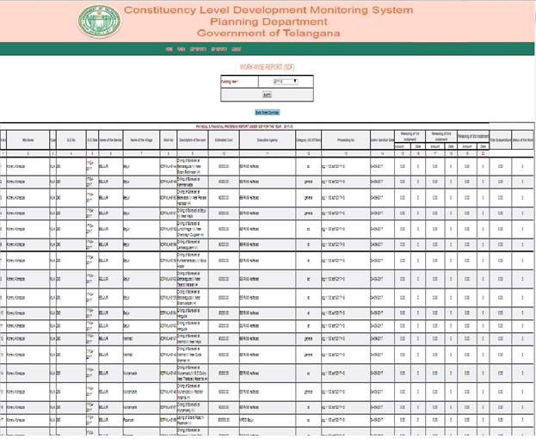

To close the application click on Logout.

